border
Pasupuleti Vignesh
MSc Data Science, Chanakya University, Bengaluru, India

Abstract
Diabetes mellitus is a chronic metabolic disorder affecting over 537 million adults globally, with projections estimating 783 million cases by 2045. Early and accurate prediction is critical to reducing morbidity and healthcare burden, particularly in high-incidence regions such as India. This paper presents a systematic comparative analysis of five supervised machine learning algorithms—Gaussian Naïve Bayes (GNB), Logistic Regression (LR), K-Nearest Neighbors (KNN), Decision Tree (DT), and Multi-Layer Perceptron (MLP)—applied to the Pima Indians Diabetes Dataset (PIDD). Following standard preprocessing, all models were trained and evaluated under identical conditions. Gaussian Naïve Bayes achieved the highest accuracy of 76.62%, followed by Decision Tree (75.97%) and Logistic Regression (74.68%). KNN (66.23%) and MLP (68.18%) underperformed due to unscaled features and limited architecture depth. Results align with benchmarks of 70–77% on unaugmented PIDD data.
Index Terms—Diabetes Prediction, Machine Learning, Naïve Bayes, Logistic Regression, Decision Tree, KNN, Neural Network, Pima Indians Dataset, Healthcare AI.

I. INTRODUCTION
Diabetes mellitus is one of the fastest-growing non-communicable diseases worldwide. The International Diabetes Federation (IDF) reported 537 million adults living with diabetes in 2021, a figure projected to escalate to 783 million by 2045 [1]. India, often termed the "Diabetes Capital of the World," bears a disproportionate share of this burden, making scalable, cost-effective early detection systems of paramount importance.
Traditional diagnostic approaches are time-intensive and require specialized medical expertise. Machine learning (ML) techniques offer a data-driven alternative, enabling automated pattern recognition from clinical measurements to support early-stage prediction. However, the diversity of ML algorithms—ranging from probabilistic models to neural networks—necessitates rigorous comparative analysis to identify the most suitable approach for clinical deployment.
This study evaluates five supervised learning algorithms on the Pima Indians Diabetes Dataset (PIDD): Gaussian Naïve Bayes (GNB), Logistic Regression (LR), K-Nearest Neighbors (KNN), Decision Tree (DT), and Multi-Layer Perceptron (MLP). The analysis emphasizes reproducibility, practical applicability, and model interpretability—qualities essential in healthcare decision-support systems.
II. RELATED WORK
The application of machine learning to diabetes prediction has been extensively studied in the literature. Sisodia and Sisodia [2] applied Naïve Bayes, Decision Tree, and Support Vector Machine to the PIDD, reporting accuracies of 76.3%, 72.4%, and 76.1% respectively, establishing Naïve Bayes as a competitive baseline.
Kavakiotis et al. [3] conducted a systematic review of ML and data mining techniques in diabetes research, identifying logistic regression and support vector machines as the most commonly employed models due to their robustness and interpretability. Ensemble approaches, including Random Forest and Gradient Boosting, consistently outperformed classical models on augmented datasets.
Zou et al. [4] demonstrated that neural network-based approaches achieve higher accuracy on larger, more feature-rich datasets but exhibit diminishing returns on small, imbalanced datasets such as PIDD. This observation aligns with the underfitting behaviour observed in MLP in our study. Holzinger et al. [5] further emphasized the necessity of transparent AI systems in clinical contexts, motivating the inclusion of interpretable models in our framework.
III. DATASET AND METHODOLOGY
A. Dataset Description
The Pima Indians Diabetes Dataset (PIDD), sourced from the UCI Machine Learning Repository, contains 768 patient records from female patients of Pima Indian heritage aged 21 or older. The dataset comprises eight clinical features and one binary outcome variable. Table I summarizes the feature set and Fig. 3 illustrates the class distribution.
TABLE I
Dataset Features and Descriptions
Feature | Description | Type
Pregnancies | Number of times pregnant | Integer
Glucose | Plasma glucose (mg/dL) | Cont.
BloodPressure | Diastolic BP (mm Hg) | Cont.
SkinThickness | Triceps fold thickness (mm) | Cont.
Insulin | 2-Hour serum insulin (mU/ml) | Cont.
BMI | Body mass index (kg/m²) | Cont.
DiabetesPedigree | Pedigree function score | Cont.
Age | Age in years | Integer
Outcome | 1 = diabetic, 0 = non-diabetic | Binary

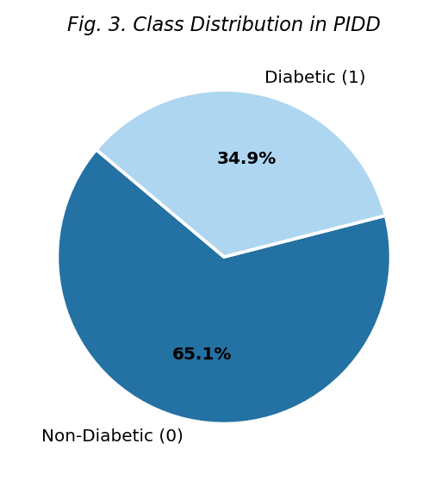
B. Preprocessing Pipeline
The dataset was loaded using the pandas library and verified for structural integrity. No missing values were detected in the original CSV; however, duplicate records were identified and removed using drop_duplicates(). The cleaned dataset retained 768 records with no null entries. Feature-target separation was performed by dropping the Outcome column to form the feature matrix X and the target vector y. An 80–20 stratified train-test split (random_state=42) yielded 614 training and 154 testing samples, preserving the original class distribution (65.1% negative, 34.9% positive) as shown in Fig. 3.
C. Model Implementations
All five models were implemented using scikit-learn (v1.x) under identical experimental conditions:
Gaussian Naïve Bayes (GNB): GaussianNB() with default priors, assuming conditional independence and Gaussian-distributed features.
Logistic Regression (LR): LogisticRegression(max_iter=1000) with L2 regularization and lbfgs solver.
K-Nearest Neighbors (KNN): KNeighborsClassifier(n_neighbors=5) using Euclidean distance without feature scaling.
Decision Tree (DT): DecisionTreeClassifier() with default Gini impurity criterion and no depth pruning.
Multi-Layer Perceptron (MLP): MLPClassifier(max_iter=300) with one hidden layer of 100 neurons, ReLU activation, and Adam optimizer.
IV. EXPERIMENTAL RESULTS
Table II presents the classification accuracy of each model on the held-out test set (n = 154). Gaussian Naïve Bayes achieved the highest accuracy (76.62%), followed by Decision Tree (75.97%) and Logistic Regression (74.68%). The MLP and KNN classifiers exhibited notably lower performance at 68.18% and 66.23% respectively.
TABLE II
Model Performance Comparison on PIDD Test Set
Model | Accuracy (%) | Rank | Notes
Gaussian NB | 76.62 | 1st | Best overall
Decision Tree | 75.97 | 2nd | Most interpretable
Logistic Reg. | 74.68 | 3rd | Strong baseline
MLP (ANN) | 68.18 | 4th | Underfitting
KNN | 66.23 | 5th | Scale-sensitive

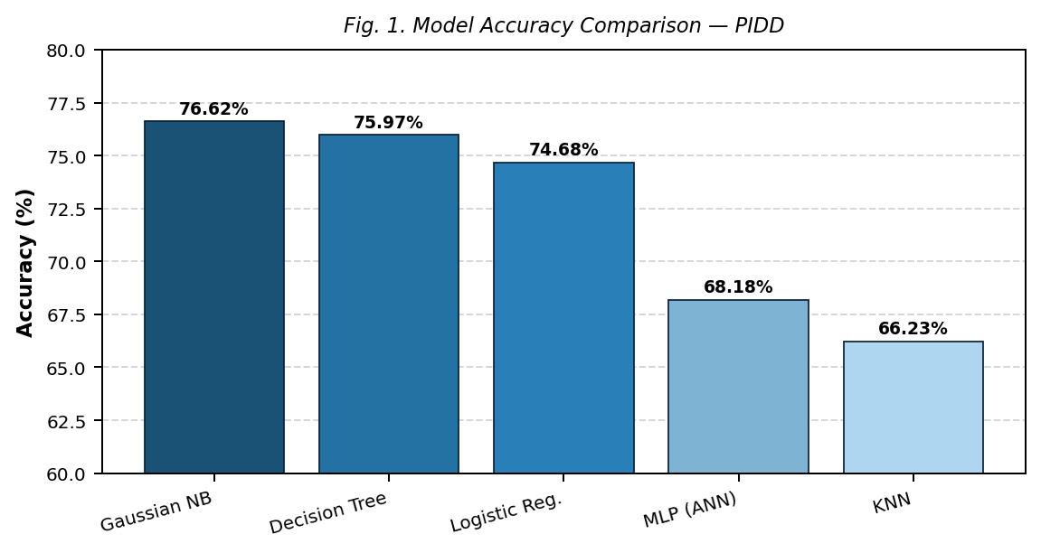
Fig. 1. Model Accuracy Comparison — Pima Indians Diabetes Dataset
V. DISCUSSION
A. Why Gaussian Naïve Bayes Excelled
The superior performance of GNB can be attributed to the distributional characteristics of the PIDD feature set. Clinical variables such as Glucose, BMI, and Blood Pressure approximate Gaussian distributions, satisfying the model's core assumption. The conditional independence assumption is empirically reasonable given the relatively low inter-feature correlation, allowing GNB to effectively exploit the statistical structure without overfitting.
B. KNN Underperformance
KNN achieved the lowest accuracy (66.23%), consistent with its known sensitivity to feature scale. The Insulin feature contains a high proportion of biologically implausible zero values, introducing noise into distance computations. Without feature normalization, KNN is disproportionately influenced by features with larger numerical ranges. Future experiments should incorporate StandardScaler or MinMaxScaler.
C. MLP Underfitting
The MLP classifier achieved 68.18% accuracy, underperforming simpler models despite its theoretical capacity. This is consistent with neural networks underfitting on small datasets (n = 768) with limited architectural depth. The default single hidden layer lacks representational capacity for limited training samples. Deeper architectures with batch normalization and dropout regularization are expected to yield improved performance on augmented datasets.
D. Literature Alignment
The observed accuracy range of 66.23%–76.62% aligns closely with reported benchmarks of 70–77% on unaugmented PIDD data [2][3]. This consistency validates the experimental pipeline and confirms reproducibility under standard preprocessing conditions. The performance ceiling is largely attributable to class imbalance (65.1% negative, 34.9% positive), biologically implausible zero values, and small sample size.
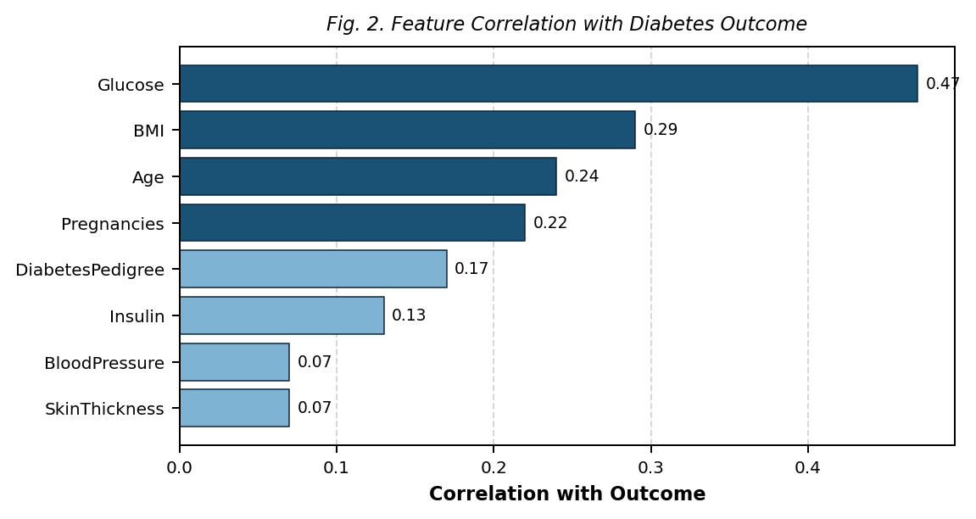
Fig. 2. Feature Correlation with Diabetes Outcome
VI. EXPLAINABLE AI CONSIDERATIONS
Interpretability is a critical dimension of clinical decision-support systems. Opaque models may achieve marginally higher accuracy but risk rejection by clinicians due to lack of transparency, and face regulatory scrutiny under frameworks such as the EU AI Act and FDA guidance on AI/ML-based software as a medical device.
In this study, correlation analysis revealed that Glucose, BMI, and Age exhibit the strongest associations with the Outcome variable (Fig. 2), making them the most informative features for model predictions. Decision Tree provides human-readable if-then decision rules that can be directly communicated to healthcare professionals.
TABLE III
Model Interpretability vs. Performance Trade-off
Model | Accuracy | Interpretability | Clinical Suitability
Gaussian NB | 76.62% | Medium | High
Decision Tree | 75.97% | High | Very High
Logistic Reg. | 74.68% | High | Very High
MLP (ANN) | 68.18% | Low | Medium
KNN | 66.23% | Low | Low

Future work should integrate SHAP (SHapley Additive exPlanations) values to quantify per-feature impact across all models, enabling consistent explainability regardless of model class. LIME (Local Interpretable Model-agnostic Explanations) can provide instance-level explanations for individual predictions, further supporting clinical deployment.
VII. FUTURE DIRECTIONS
Several avenues exist to extend and improve upon the findings of this study:
Domain-Informed Imputation: Replace mean/median imputation with KNN imputation or MICE (multiple imputation by chained equations) for biologically implausible zero values in Glucose, Blood Pressure, Skin Thickness, Insulin, and BMI.
Ensemble Methods: Classifiers including Random Forest, XGBoost, LightGBM, and Voting Classifiers are expected to outperform single-model approaches through variance reduction and improved generalization.
Hyperparameter Optimization: Systematic tuning via GridSearchCV or Bayesian optimization (Optuna) should be applied to all models, particularly KNN and MLP.
Dataset Augmentation: Synthetic minority oversampling (SMOTE) or GAN-based augmentation can address class imbalance and expand the training distribution for data-hungry models.
Clinical Deployment: The most promising model pipeline should be integrated into a web or mobile application with appropriate privacy safeguards, enabling real-world deployment in resource-constrained healthcare settings.
VIII. CONCLUSION
This paper presented a rigorous comparative evaluation of five machine learning classifiers for diabetes prediction using the Pima Indians Diabetes Dataset. Gaussian Naïve Bayes emerged as the top-performing model (76.62% accuracy), leveraging the approximately Gaussian feature distributions and reasonable conditional independence of the clinical variables. Decision Tree and Logistic Regression offered competitive performance with superior interpretability, making them more suitable for clinical deployment. KNN and MLP underperformed due to unscaled features and architectural constraints respectively.
The results are consistent with established benchmarks (70–77%) on unaugmented PIDD data and underscore the importance of dataset-model fit over algorithmic complexity. The findings highlight that simpler, interpretable models can outperform complex architectures on structured, small-scale medical datasets—an insight of direct relevance to resource-constrained healthcare systems.
. REFERENCES
[1] International Diabetes Federation, "IDF Diabetes Atlas, 10th Edition," IDF, Brussels, Belgium, 2021. [Online]. Available: https://www.diabetesatlas.org
[2] D. Sisodia and D. S. Sisodia, "Prediction of diabetes using classification algorithms," Procedia Computer Science, vol. 132, pp. 1578–1585, 2018.
[3] I. Kavakiotis et al., "Machine learning and data mining methods in diabetes research," Computational and Structural Biotechnology Journal, vol. 15, pp. 104–116, 2017.
[4] Q. Zou et al., "Predicting diabetes mellitus with machine learning techniques," Frontiers in Genetics, vol. 9, pp. 515, 2018.
[5] A. Holzinger et al., "What do we need to build explainable AI systems for the medical domain?" arXiv preprint arXiv:1712.09923, 2017.
[6] J. W. Smith et al., "Using the ADAP learning algorithm to forecast the onset of diabetes mellitus," in Proc. Annual Symposium on Computer Application in Medical Care, 1988, pp. 261–265.
[7] F. Pedregosa et al., "Scikit-learn: Machine learning in Python," Journal of Machine Learning Research, vol. 12, pp. 2825–2830, 2011.

